Resources for Children and Teens dealing with Death and Loss

The Children's Bereavement Center is a local provider of free Peer Support Groups for children, young adults, and adult caregivers after the death of a loved one. Groups are open to anyone who has lost a parent, sibling, grandparent, relative, or friend as a result of illness, accident, suicide, or homicide. Since May, the weekly group session is being help online instead of in-person. 305.668.4902
https://childbereavement.org/

Books about Death and Loss for Children and Teens
This book list, which includes picture books for young children, includes a selection of fiction and non-fiction books that deal with death, grief, and loss.

- 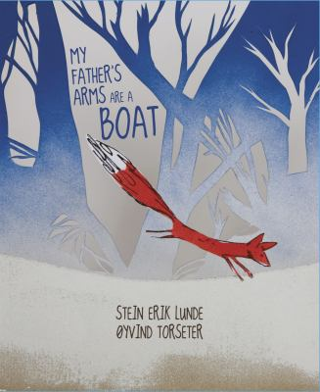
My father’s arms are a boat
Unable to sleep, a young boy climbs into his father's arms and asks about birds, foxes, and whether his mother will ever awaken, then under a starry sky, the father provides clear answers and assurances.
- 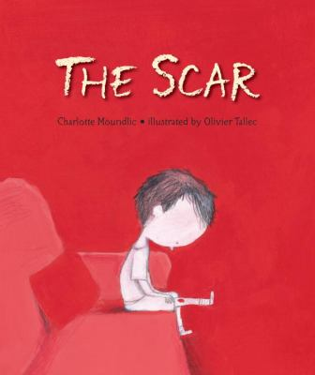
The scar
When his mother dies, a little boy is angry at his loss but does everything he can to hold onto the memory of her scent, her voice, and the special things she did for him, even as he tries to help his father and grandmother cope.
- 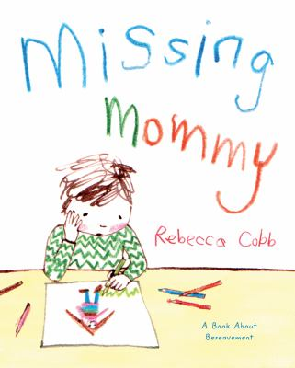
Missing mommy
Honest and straightforward, this touching story explores the many emotions a bereaved child may experience, from anger and guilt to sadness and bewilderment. Ultimately, Missing Mommy focuses on the positive―the recognition that the child is not alone but still part of a family that loves and supports him.
- 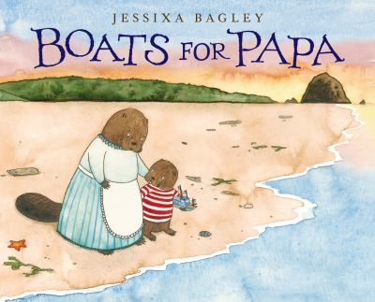
Boats for Papa
Buckley and his mother cope with the loss of their father/husband by sending small wooden boats, built by Buckley, off into the ocean.
- 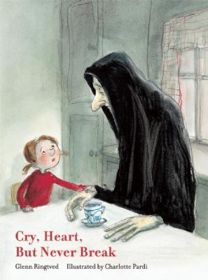
Cry heart, but never break
Aware their grandmother is gravely ill, four siblings make a pact to keep death from taking her away. But Death does arrive all the same, as it must. He comes gently, naturally. And he comes with enough time to share a story with the children that helps them to realize the value of loss to life and the importance of being able to say goodbye.
- 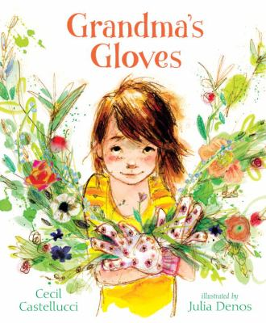
Grandma's gloves
When her grandmother, a devoted gardener, dies, a little girl inherits her gardening gloves and feels closer to her memory.
- 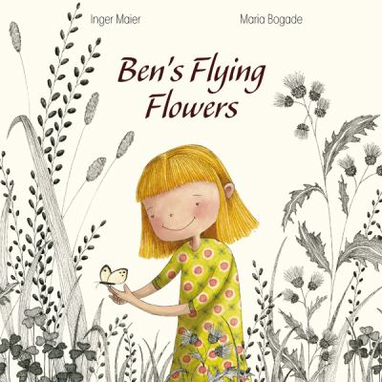
Ben's flying flowers
Emily introduces her younger brother, Ben, to butterflies, which he calls "flying flowers," and when his illness makes him too weak to go see them she draws him pictures, but after his death she no longer wants to draw happy things. Includes note to parents.
- 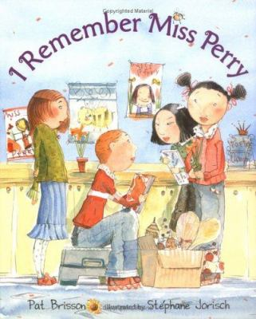
I Remember Miss Perry
When his teacher, Miss Perry, is killed in a car accident, Stevie and his elementary school classmates take turns sharing memories of her, especially her fondest wish for each day.
- 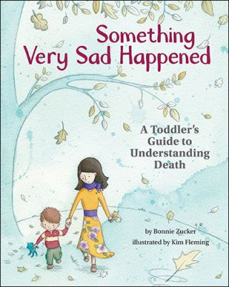
Something very sad happened: a toddler's guide to understanding death
Something Very Sad Happened is a useful tool for parents, caregivers, therapists, and teachers to help young children understand the concept of death and begin the process of coping with the loss. Intended for children ages 2 and 3, the book explains death and loss to a very young child in a simple and age-appropriate way. It also serves as a starting point for discussion when parents or other adults may be grieving.
- 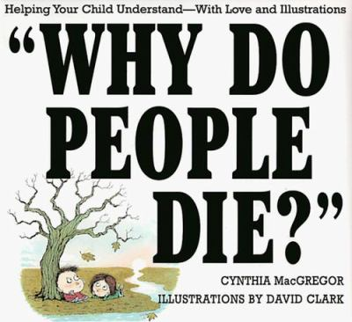
Why do people die? Helping your child understand--with love and illustrations
Explains death, its effect on the living, and some of the beliefs, customs, and rituals associated with it.
- 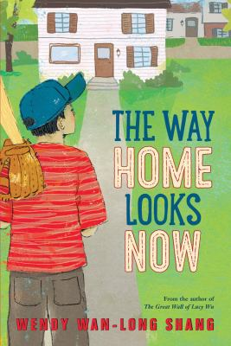
The way home looks now
In 1972, after his older brother is killed in a car crash, Peter Lee's mother is paralyzed by grief and his traditional Chinese father seems emotionally frozen; but Peter hopes that if he joins a Little League team in Pittsburgh he can reawaken the passion for baseball that all the members of his family used to share and bring them back to life.
- 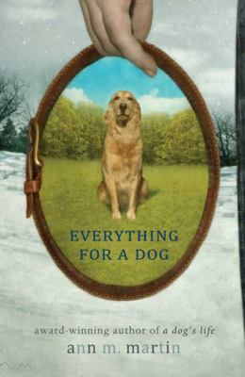
Everything for a dog
In parallel stories, Bone, an orphaned dog, finds and loses a series of homes, Molly, a family pet, helps Charlie through the grief and other after-effects of his brother's death, and lonely Henry pleads for a dog of his own.
Untwine
Identical twin teenagers Giselle and Isabelle Boyer have always been inseparable, and expected to stay that way even though their Haitian American parents are separating--but when the entire family is caught in a car crash, everyone's world is shattered forever.
- 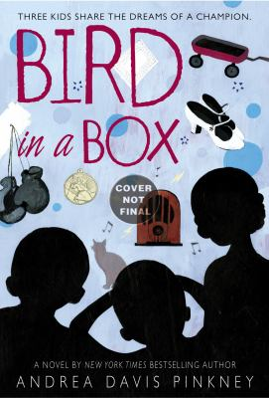
Bird in a box
In 1936, three children meet at the Mercy Home for Negro Orphans in New York State, and while not all three are orphans, they are all dealing with grief and loss which together, along with the help of a sympathetic staff member and the boxing matches of Joe Louis, they manage to overcome.
- 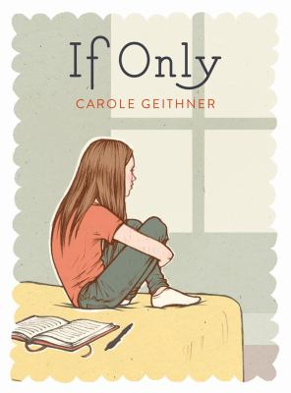
If only
Corinna's world is crushed after her mother dies of cancer. How does she get through the funeral, trays of ziti, a father who can't communicate, the first day of school, Mother's Day, people who don't know what to say, and the entire eighth-grade year? Despite her alienation from many of her peers, including her best friend, she succeeds in finding support. She dares to bare her innermost fears, hurts, and wishes, and even allows herself to have a flowering crush on a boy in the school band. She also finds out deep secrets about her mother which she never knew. It's a year that will change Corinna's life forever.
- 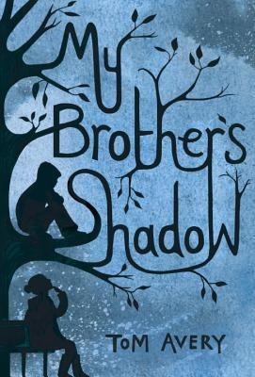
My Brother's Shadow
Eleven-year-old Kaia, who has felt emotionally isolated since her brother's suicide, befriends a wild boy who mysteriously appears at her London school, finding a way to communicate with him despite his being mute.
Love, Aubrey
A beautifully written and deeply moving middle-grade novel with characters to cherish and a story that deals with tragedy and loss in a fresh way. Aubrey has suffered an unbelievable loss, and goes to live with her grandmother in Vermont in order to heal. There she makes new friends, learns to cope with what has happened, and begins to figure out how to move on. Readers will fall in love with Aubrey from page one, and hold their breath until the very end, when she has to make one of the biggest decisions of her life.
- 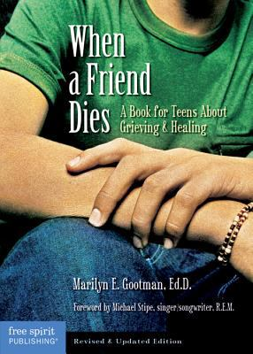
When a friend dies: a book for teens about grieving & healing
The death of a friend is a wrenching event for anyone at any age. Teenagers especially need help coping with this painful loss. This sensitive book answers questions grieving teens often have, like “How should I be acting?” “Is it wrong to go to parties and have fun?” and “What if I can’t handle my grief on my own?”
- You are not alone: teens talk about life after the loss of a parent
- 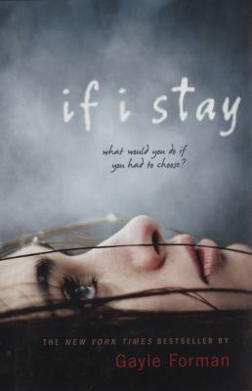
If I stay
While in a coma following an automobile accident that killed her parents and younger brother, seventeen-year-old Mia, a gifted cellist, weighs whether to live with her grief or join her family in death.
- 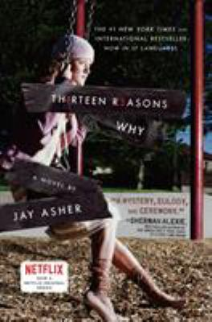
Th1rteen r3asons why
When high school student Clay Jenkins receives a box in the mail containing thirteen cassette tapes recorded by his classmate Hannah, who committed suicide, he spends a bewildering and heartbreaking night crisscrossing their town, listening to Hannah's voice recounting the events leading up to her death.
- 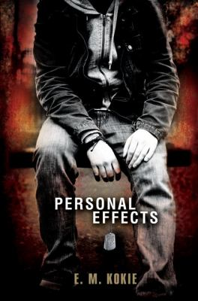
Personal effects
Matt has been sleepwalking through life while seeking answers about his brother T.J.'s death in Iraq, but after discovering that he may not have known his brother as well as he thought he did, Matt is able to stand up to his father, honor T.J.'s memory, and take charge of his own life.
- 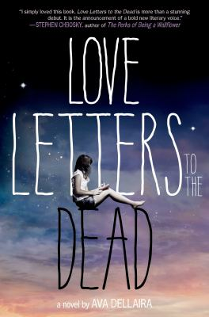
Love letters to the dead
When Laurel starts writing letters to dead people for a school assignment, she begins to spill about her sister's mysterious death, her mother's departure from the family, her new friends, and her first love.
- 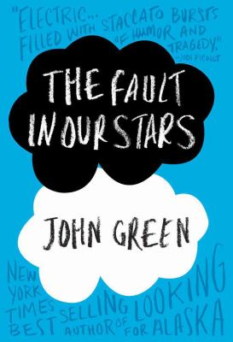
The fault in our stars
Sixteen-year-old Hazel, a stage IV thyroid cancer patient, has accepted her terminal diagnosis until a chance meeting with a boy at cancer support group forces her to reexamine her perspective on love, loss, and life.
- 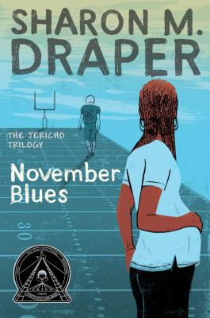
November blues
A teenaged boy's death in a hazing accident has lasting effects on his pregnant girlfriend and his guilt-ridden cousin, who gives up a promising music career to play football during his senior year in high school.
The truth about forever
The summer following her father's death, Macy plans to work at the library and wait for her brainy boyfriend to return from camp, but instead she goes to work at a catering business where she makes new friends and finally faces her grief.
- 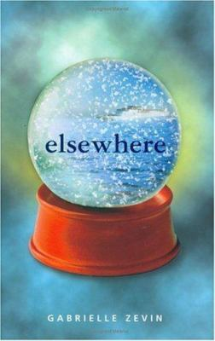
Elsewhere
After fifteen-year-old Liz Hall is hit by a taxi and killed, she finds herself in a place that is both like and unlike Earth, where she must adjust to her new status and figure out how to "live."
The last time we say goodbye
After her younger brother, Tyler, commits suicide, Lex struggles to work through her grief in the face of a family that has fallen apart, the sudden distance between her and her friends, and memories of Tyler that still feel all too real.
Amy and Roger's epic detour
After the death of her father, Amy, a high school student, and Roger, a college freshman, set out on a carefully planned road trip from California to Connecticut, but wind up taking many detours, forcing Amy to face her worst fears and come to terms with her grief and guilt.
- 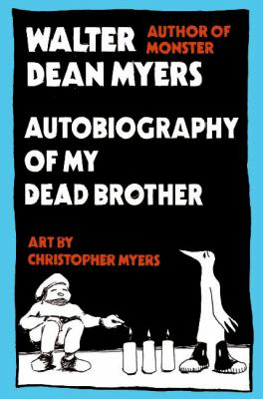
Autobiography of my dead brother
Jesse uses his sketchbook and comic strips to make sense of his home in Harlem and the loss of a close friendship. The thing was that me and Rise were blood brothers, but sometimes I really didn't know him. . . . And so Jesse fills his sketchbook with drawings and portraits of his blood brother, Rise, and his comic strip, Spodi Roti and Wise, as he makes sense of the complexities of friendship, loyalty, and loss in a neighborhood where drive-bys, vicious gangs, and abusive cops are everyday realities.
The sister pact
Allie is devastated when her sister Leah commits suicide--and not just because she misses her. The two teens made a suicide pact so that they'd always be together, and Allie can't understand why she was left behind
- 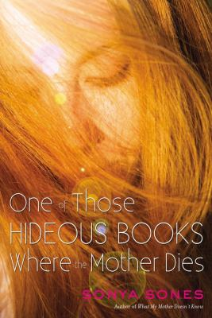
One of those hideous books where the mother dies
Fifteen-year-old Ruby Milliken leaves her best friend, her boyfriend, her aunt, and her mother's grave in Boston and reluctantly flies to Los Angeles to live with her father, a famous movie star who divorced her mother before Ruby was born.

